

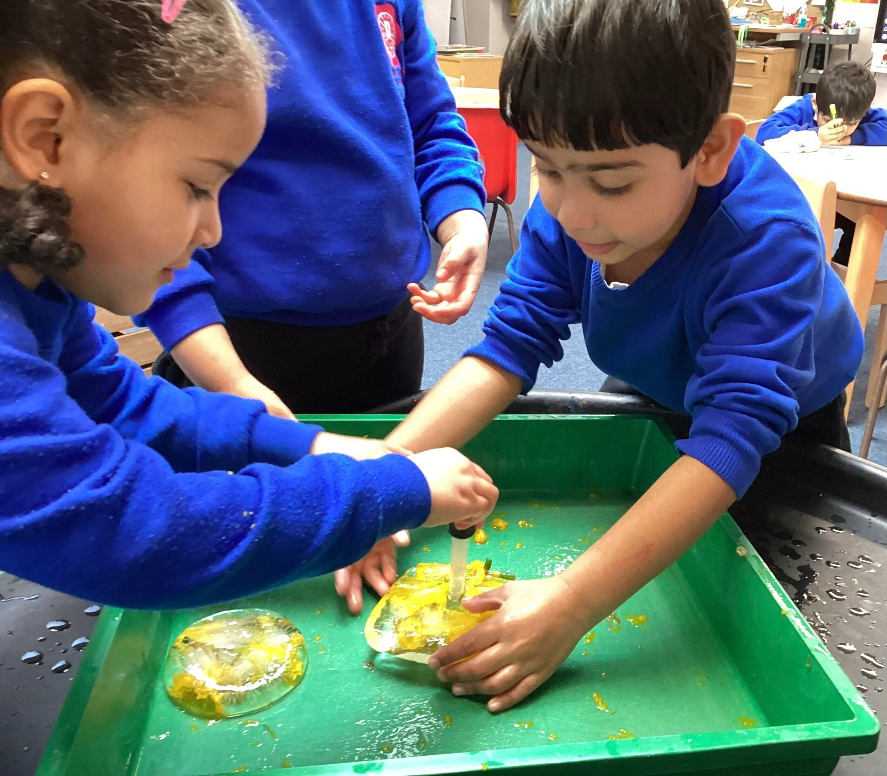



Pupil Questionnaire Feedback
Summer 2025
West Alvington Cof E Academy

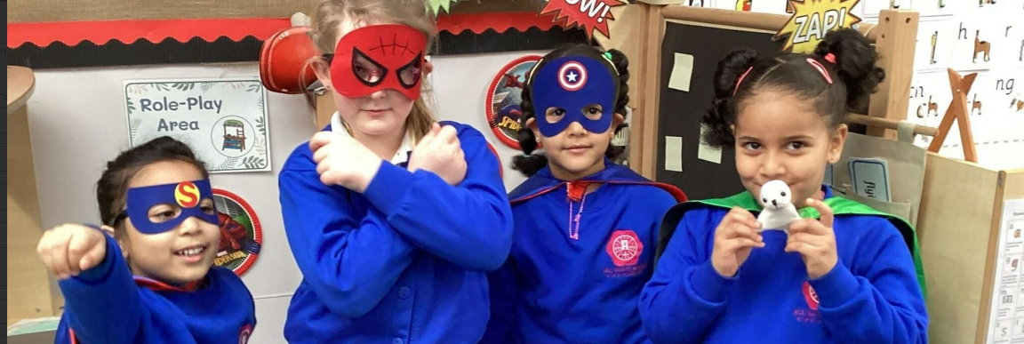

We received a total of 21 responses from pupils across our School, which gives an 60% response rate.

“Respect treat people equally, honesty helps us to tell the truth, responsibility look after the classroom and our school, friendship, tells us to be kind and help the little ones in our school”

I feel listened to and have a voice in my class and my school community?

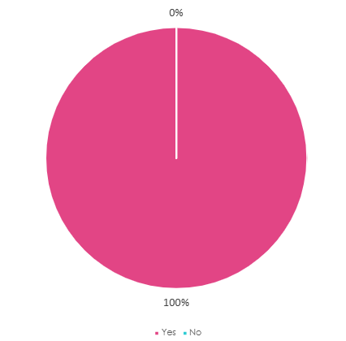

I am proud to attend my school

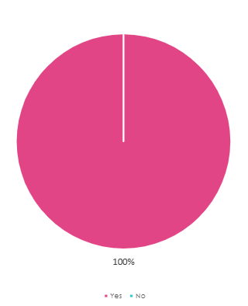

100% of pupils who say that they feel listened to in class and in their school community.



100% of pupils who answered the questionnaire said that they were proud to attend West Alvington.

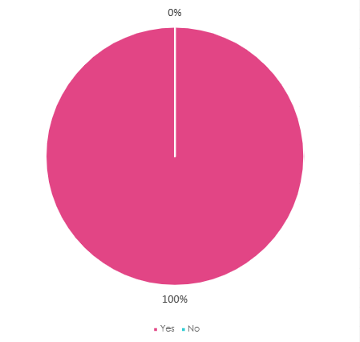
Do the school values help you to understand how to live together as a school family?

My teacher(s) knows me and understands how I learn
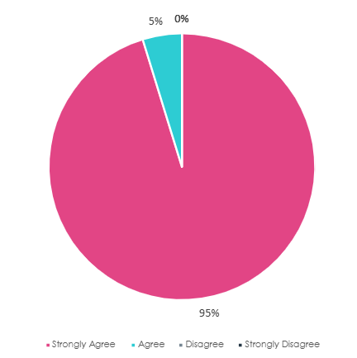

Does your teacher help you when you find things hard?
What motivates you to learn more?
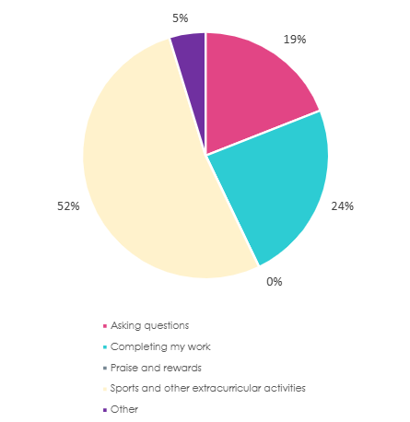

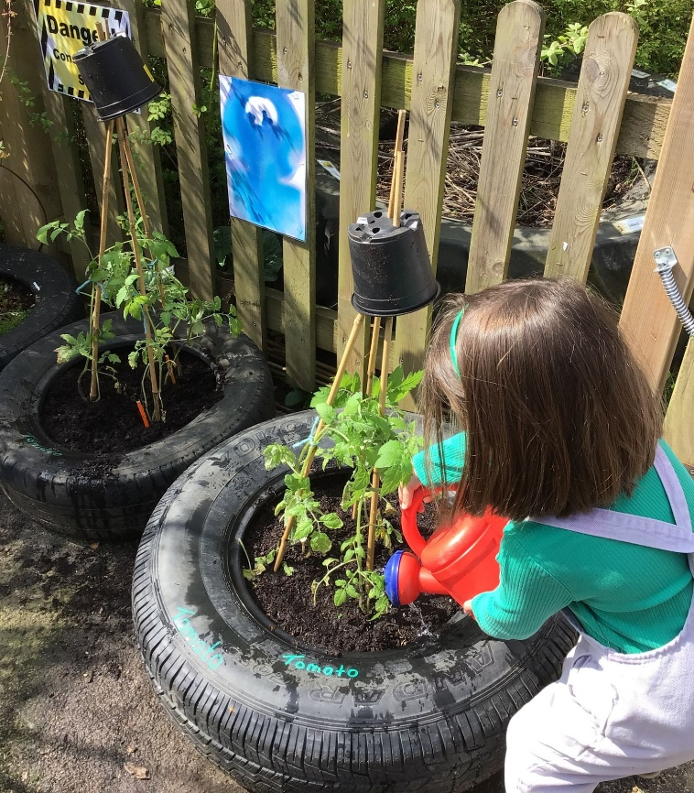
ADD ANALYSIS WORDAGE

What are you proud of achieving in class / school this year?

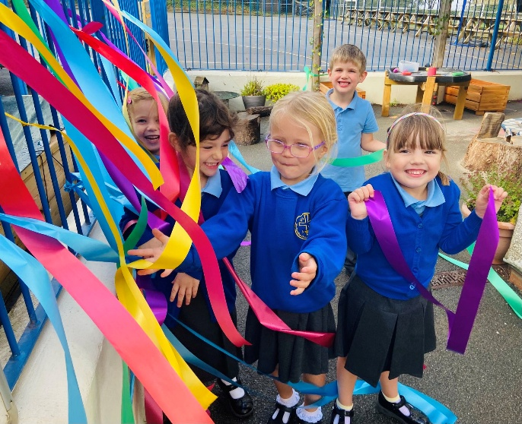

Given a chance, what is the one change that you would like to see in your school or class?

I would love to learn sign language - it would help improve our class.

Some more equipment in the playground.

Play football against other schools, semi premier league - winner goes on a school trip!

I have opportunities to learn about lots of different subjects



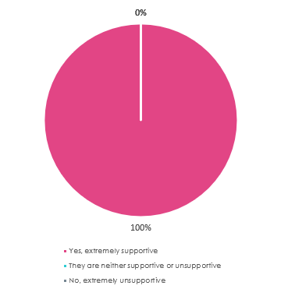
In my class there are clear expectations for behaviour and it's fair
“ We need our values to make us feel calm and not worried about coming into school”

Do you have supportive classmates?

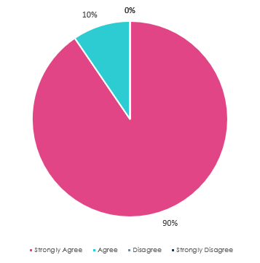

Do you think that the school provides you with enough sports / musical opportunities?

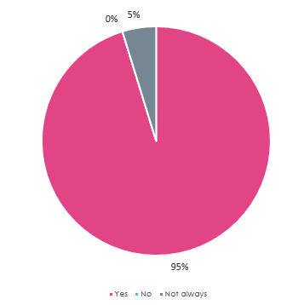

I know how to keep myself safe online
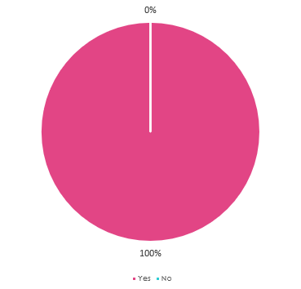

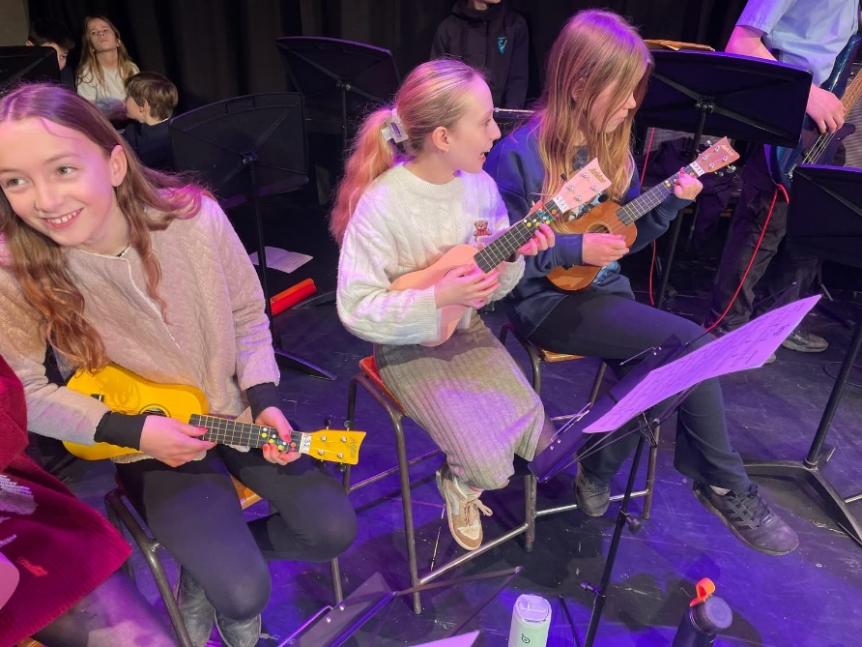

ADD ANALYSIS WORDAGE

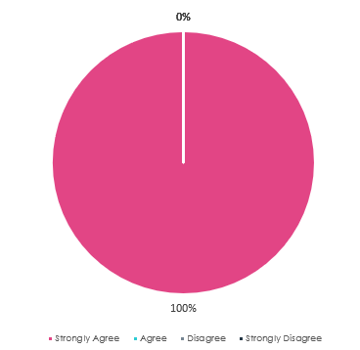
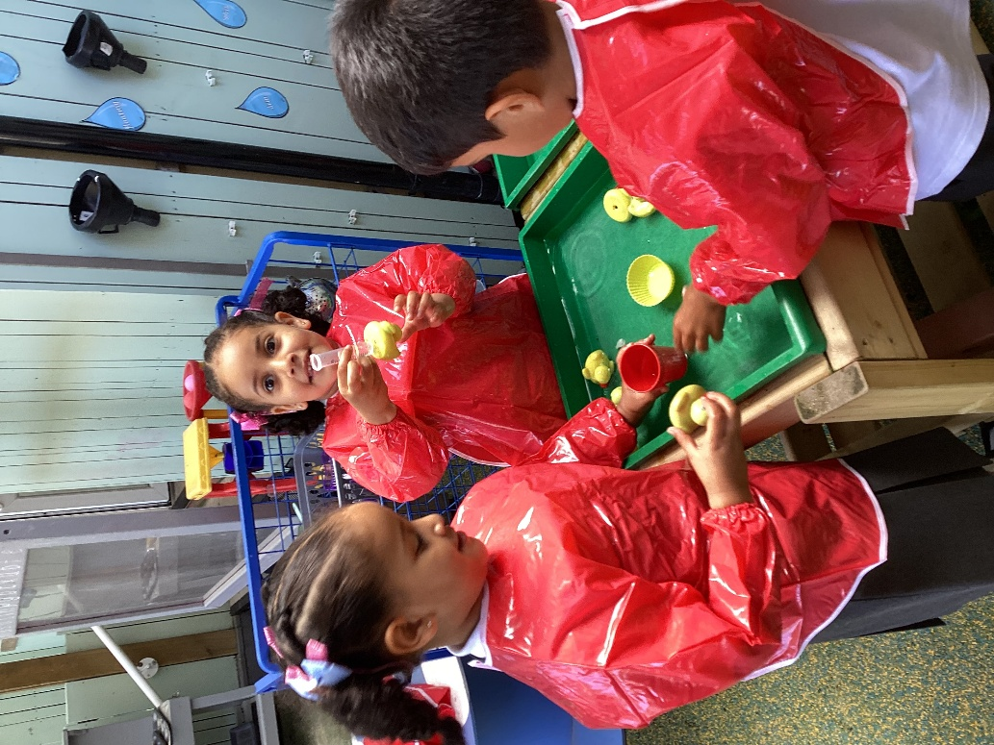
If I told someone at school I was worried about something they would help me

ADD ANALYSIS WORDAGE

“We grow and flourish together, we are a small school and we care and look after each other”

Once again, we have some really clear, invaluable feedback from our pupils and actions to take moving forwards.
Our pupils want to be part of a bigger family and value the work that has been done so far to achieve this.
It’s great to hear that they like it, and they want even more!

Your school is part of a family of schools. What sort of things would you like to be able to do with other schools in our Trust?

- Sporting events and trips
- Football tournaments and trips.

- More whole Trust residential - I loved the Slapton residential in Year 4. Whole trust class trips so that we get to know each other before KCC

- Residential was good, I see people now that I wave to in Morrisons that I met, makes me more confident

- I would like to be able to have a whole school meet up with all the other schools



