Hazel Class 2024-2025

Summer Term Curriculum EYFS Overview

Welcome to **Hazel** Class!

# The children have a wonderful term of adventure, activities and learning awaiting them! Keep reading to see what we will be up to over the coming weeks!

**Transition**

The Summer term always promises an incredible amount of learning as the children prepare for life in Year 1, and this term is no exception! We will be learning about what life is like in Year 1 before Shuffle Up Day later this term by interviewing some of the Year 1s about their experiences.

Our learning this term is based upon a range of high-quality texts that will expose the children to a rich range of language and vocabulary, enhanced by stunning illustrations, allowing the children to become lost in truly stunning stories as they explore the world.

The children will adore the breathtaking learning opportunities and experiences planned for this term which will leave them wanting more!

# The Characteristics of Effective Learning - helping us to learn!

In the EYFS, we refer to the Characteristics of Effective Learning. These characteristics detail the ways in which children should be learning from their environment, experiences and activities. Children will display these characteristics every day during their time in Hazel, and beyond. The characteristics of effective learning are split into three main areas. These are:

* **Playing and Exploring:** this shows how the child *is engaging*.
* **Actively Learning:** shows the *motivation* behind the child’s learning
* **Creating and Thinking Critically**: this shows the *thought* processes behind learning and new achievements

In Hazel, we talk about these characteristics on a daily basis with our little ones in a child-friendly way of talking about their learning and the choices they have made, as well as helping them to learn life skills and to reinforce positive values within our class and the wider academy community.

**Our themes**

Each week the children will have a different theme to inspire their learning and promote curiosity.

Our weekly themes will be as follows:

Rosa Parks All things Phonics

Africa Dinosaurs and Fossils

The 4 Seasons Insects

Sunflowers and Plants At the Seaside

Road Safety Under the sea

Florence Nightingale Summer

**The Prime Areas: putting in solid foundations**

Throughout the Summer term, we reflect back on the fabulous foundations the children have developed over the past two terms in their Prime Areas of Personal, Social and Emotional Development (PSED), Communication and Language (CL) and Physical Development (PD). The Prime Areas underpin every other aspect of a child’s development and learning throughout their time in the EYFS and beyond. In Hazel, we ensure that these foundation elements are strong and well developed enabling them to learn to soar through a successful lifetime of learning.

PSED

PSED underpins and flows throughout all our learning in Hazel, helping us to learn and play alongside our friends. We will continue to strengthen our understanding and respect of others, as well as how we can make good choices, beam with confidence and independence, persevere and be resilient, understand the idea of consequences and how to be a good friend.

As a class, we continue to refer to and use the Class Charter we wrote in September, helping us to show the fabulous learning behaviours we are famous for in Hazel. The children have several opportunities on a daily basis to undertake roles of responsibility, whether they are in charge of tidying up, handing out our snacks or acting as Line Leader. As Miss Cose prepares to welcome the new cohort in, the children will act as guides and mentors, sharing their learning with the new children and showing them how wonderful life is here in Hazel!

Communication & Language

The children are taught in a language rich environment, exposing them to a plethora of vocabulary and explanations that help to deepen their learning and thinking. This area covers the skills of listening, speaking and thinking about their use of language. This is a key priority and we plan opportunities on a daily basis to enhance every child’s Communication and Language. This term we will be focusing on linking events to our own experiences, using past and future tense, asking and answering ‘why’ questions and being able to retell the traditional tales The Enormous Turnip and Jack and the Beanstalk.

Physical Development

In Hazel we provide numerous daily opportunities for the children to develop their coordination, control, and movement. The children will develop their fine motor skills through Finger Gym challenges focusing on the following skills: stacking and balancing, pinching, weaving, wrapping and scissor skills. We will also develop gross motor skills through our PE sessions. In Hazel, we help children to understand the importance of a range of physical activity and to make healthy choices in relation to food.

**Mathematics**

As mathematicians this term, the children in Reception and Year 1 will engage in a range of learning opportunities that allow them to deepen their understanding and apply their thinking to their understanding of 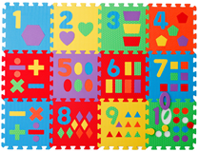more complex number challenges such as doubling and odd and even. The children will also have the opportunity to learn about patterns and maps and directions.

We will use a range of practical, real life problems to draw out the children’s thinking through mathematical discussions and learning opportunities in the environment. One of our main focusses this term will be sharing and grouping. The children will be encouraged to record their mathematical thinking in a way that is meaningful to them.

Given the fantastic foundation the children have built so far this year, they are in a brilliant place to make the move into Year 1!

**Early Literacy, Reading & Phonics**

The development of Literacy here in Hazel Class is focused on the immersion of the children in a language rich environment, securing their enjoyment and engagement with the written and spoken word. 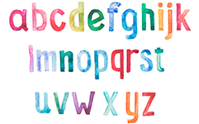

We will share a variety of high quality texts, both fiction and non-fiction to explore authorial voice and writerly craft in an age appropriate way. The children will be introduced to and deepen their love of storytelling through our *Fab Five* books and lots of gorgeously written class stories.

Phonics is taught using the *Read Write Inc.* programme which teaches children to read accurately and fluently with good comprehension. They learn to form each letter, spell correctly, and compose their ideas step-by-step.

The children will be introduced to writing or different purposes such as letters, poems, instructions and descriptions.

The children in Reception will be encouraged and supported to mark make and write by tapping into their interests through a range of learning opportunities throughout the learning environment and through their Learning Play.

**Understanding the World**

We are extremely lucky that our lovely school is set in such a breath-taking position overlooking a beautiful patchwork of fields. Over the course of the year, every child in school will have Forest School throughout the terms. These opportunities allow the children to engage with and explore the local area. We look at the variety of wild plants and flowers, fields, and hedgerows. We will also observe and describe the seasonal changes we notice over the coming months. 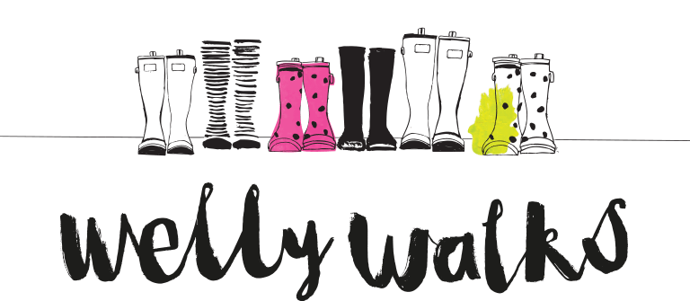

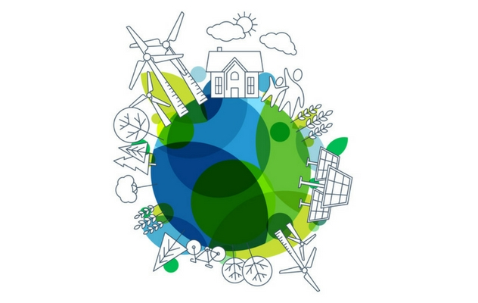The children will be developing an understanding the 4 seasons, the lifecycle of plants, how we care for plants and how our country differs to others. We will also think about we care for our world. We will continue to support their speaking and listening skills by encouraging them to explain and reason their ideas and thoughts.

We will be tapping into the exciting learning in store for the children in Years 1 and 2 who will be learning about Australia and The Great Fire of London.

**Religious Education**

As global citizens, the Reception children will be exploring some of the different teachings of Jesus as well as looking at the Christian Easter story. The children will also have the opportunity to explore a range of different places of worship.

**Art & Design**

As artists and designers in Hazel, we will be investigating and experimenting with a range of materials. We will learn how to work with paper, creating a variety of joins. The children will have numerous opportunities to practise colour techniques, including colour mixing, shade and tone. They will also get the chance to again, to tap into the learning of the Years 1 and 2 and explore the skill of printing.

**Computing**

As users and programmers of communication and information technology, we will develop our computational thinking, logical reasoning and digital literacy through using different programmes. This half term our focus is on scanning a QR code.

**PE**

As well rounded, active citizens we will have lots of opportunities for positive competition in sport and other activities to build character and self-discipline. The sports we will be focusing on this term are gymnastics and multi skills; the children will be exploring different ways of moving aesthetically to complete a performance, as well as move and manipulate a range of apparatus in team games.

**Christian Distinctiveness**

Through our daily Acts of Worship, we will reflect on how we demonstrate our Christian values in school and within our local and world communities. We also weave our Christian values into the children’s learning opportunities and activities. We will explore our values of **Service** and **Love** before we move on to celebrating the key festivals with our wider church family later in the term.

**Family Group Acts of Worship**

Each week, the children will join their friends in their Family Group to deepen their understanding of the themes covered in our whole school Acts of Worship. These sessions offer a wonderful opportunity for all children to come together and work collaboratively as a family. This term we will be deepening our understanding of our learning in Collective Worship.

**Home Learning in Hazel Class**

We value the support that parents and families provide from home. It enriches your child’s learning and helps them achieve the best that they can. In Hazel Class, we send home weekly home learning for the Reception children.

In Reception, this consists of weekly storybooks from the library which the children have chosen, and learning linked to the fabulous work that they are doing in their *Read Write Inc.* sessions. Occasionally, we may set a special project, investigation or experiment for you to work on together at home!

**Reading, Reading, Reading!**

Regular reading is of HUGE importance to the Literacy and social development of our young children. In the early days of school, it is vital that we ignite the children’s love of books and reading.

You can support your child’s reading at home by encouraging them to:

* Name any sounds they recognise, such as the ones they see in their name.
* Ask them to predict the ending to the story and explain why.
* Ask questions to help them understand and enjoy the story.
* Listen to a wide variety of pleasurable books.
* Continue to read a variety of stories to your child so that they are hearing a variety of story language and develop a love of reading.
* Don’t forget bedtime stories are still important too!