Hazel Class 2024-25

Spring Term Curriculum Overview

Welcome to **Hazel** Class!

# The children have a wonderful term of adventure, activities and learning awaiting them! Keep reading to see what we will be up to over the coming weeks!

# The Characteristics of Effective Learning - helping us to learn!

In the EYFS, we refer to the Characteristics of Effective Learning. These characteristics detail the ways in which children should be learning from their environment, experiences and activities. Children will display these characteristics every day during their time in Hazel, and beyond. The characteristics of effective learning are split into three main areas. These are:

* **Playing and Exploring:** this shows how the child *is engaging*.
* **Actively Learning:** shows the *motivation* behind the child’s learning
* **Creating and Thinking Critically**: this shows the *thought* processes behind learning and new achievements

In Hazel, we talk about these characteristics on a daily basis with our little ones in a child-friendly way of talking about their learning and the choices they have made, as well as helping them to learn life skills and to reinforce positive values within our class and the wider academy community.

**The Prime Areas: putting in solid foundations**

During the Spring term, we reflect back on the fabulous foundations the Reception children have developed in their Prime Areas of Personal, Social and Emotional Development (PSED), Communication and Language (CL) and Physical Development (PD). The Prime Areas underpin every other aspect of a child’s development and learning throughout their Reception year and beyond. In Hazel, we ensure that these foundation elements are strong and well developed enabling them to shine brightly throughout a long lifetime of learning.

PSED

PSED underpins and flows throughout all our learning in Hazel, helping us to learn and play alongside our friends. We will continue to strengthen our understanding and respect of others, as well as how we can diffuse difficult situations in a calm and fair way.

As a class, we continue to refer to and use the Class Charter we wrote in September, helping us to show the fabulous learning behaviours we are famous for in Hazel. The children have several opportunities on a daily basis to undertake roles of responsibility, whether they are in charge of tidying up, handing out our snacks or acting as Line Leader.

Communication & Language

The children are taught in a language rich environment, exposing them to a plethora of vocabulary and explanations that help to deepen their learning and thinking. This area covers the skills of listening, speaking and thinking about their use of language. This is a key priority and we plan opportunities on a daily basis to enhance every child’s Communication and Language.

Physical Development

In Hazel we provide numerous daily opportunities for the children to develop their coordination, control, and movement. The children will develop their fine motor skills through activities such as Finger Gym challenges, regular scissor, brush and pencil control activities. We will also develop gross motor skills through ball control, simple gymnastic movements and coordination in our PE sessions. In Hazel, we help children to understand the importance of a range of physical activity and to make healthy choices in relation to food.

**Mathematics**

As mathematicians this term, the children in Reception and Year 1 will engage in a range of learning opportunities that allow them to deepen their understanding and apply their thinking to their understanding of our numbers within 10, building on the solid foundations we put in place during the Autumn term thanks to our Number Sense approach. 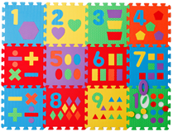

We will use a range of practical, real life problems to draw out the children’s thinking through mathematical discussions and learning opportunities in the environment. We will also explore early multiplication and division by looking at equal groups. The children will be encouraged to record their mathematical thinking in a way that is meaningful to them.

Reception children will have a daily number sense session, focussing on subitising and identifying numbers up to 10.

**Early Literacy, Reading & Phonics**

The development of Literacy here in Hazel Class is focused on the immersion of the children in a language rich environment, securing their enjoyment and engagement with the written and spoken word. 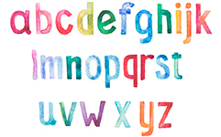

We will share a variety of high quality texts, both fiction and non-fiction to explore authorial voice and writerly craft in an age appropriate way. The children will be introduced to and deepen their love of storytelling through our *Fab Five* books and lots of gorgeously written class novels.

Phonics is taught using the *Read Write Inc.* programme which teaches children to read accurately and fluently with good comprehension. They learn to form each letter, spell correctly, and compose their ideas step-by-step.

The children in Reception will be encouraged and supported to mark make and write by tapping into their interests through a range of learning opportunities throughout the learning environment and through their Learning Play.

**The World Around Us – Science, Geography & History**

We are extremely lucky that our lovely school is set in such a breath-taking position overlooking a beautiful patchwork of fields. Over the course of the year, every child in school has the equivalent of a term at Forest School. These opportunities allow the children to engage with and explore the local area. We look at the variety of wild plants and flowers, fields, and hedgerows. We will also observe and describe the seasonal changes we notice over the coming months. 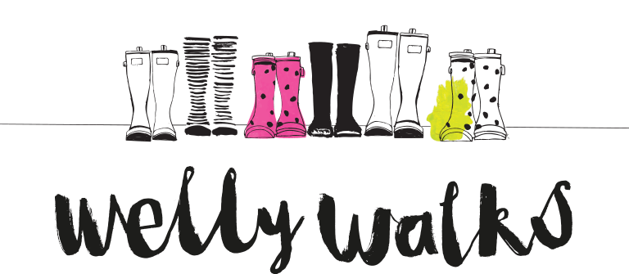

As scientists, the children will be developing an understanding of nature through scientific enquiries that help them to answer questions about the world around them. We are currently planning regular welly walks around the village to enhance and deepen the children’s learning in Science as well as to continue to support their speaking and listening skills by encouraging them to explain and reason. We will be tapping into the exciting learning in store for the children in Years 1 and 2 who will be learning about Neil Armstrong later this term!

**Religious Education**

As global citizens, the Reception children will be looking at Creation and Salvation throughout the term in Christianity through the teachings of Jesus and through the importance of his death.

**Art & Design**

As artists and designers in Hazel, we will be investigating and experimenting with a range of drawing, painting and 3D construction materials. The children will have numerous opportunities to practise colour techniques, including colour mixing, shade and tone. They will also get the chance to again, tap into the learning of the Years 1 and 2 and explore the skill of weaving.

**Design & Technology**

As designers and constructors, we will be empowered to be inquisitive, curious learners. We will be looking at how we can incorporate moving parts into our designs. We will evaluate the effectiveness of different joins and identify the most appropriate choice.

**Computing**

As users and programmers of communication and information technology, we will develop our computational thinking, logical reasoning and digital literacy through using different programmes. This half term our focus is on creativity by creating and refining our own designs using a digital tool across a range of media.

**PE**

As well rounded, active citizens we will have lots of opportunities for positive competition in sport and other activities to build character and self-discipline. The sports we will be focusing on this term are gymnastics and multi skills; the children will be exploring different ways of moving aesthetically to complete a performance, as well as move and manipulate a range of apparatus in team games.

**Christian Distinctiveness**

Through our daily Acts of Worship, we will reflect on how we demonstrate our Christian values in school and within our local and world communities. We also weave our Christian values into the children’s learning opportunities and activities. We will explore our values of **Service** and **Love** before we move on to celebrating the key festivals of **Lent and Easter** with our wider church family later in the term.

**Family Group Acts of Worship**

Each week, the children will join their friends in their Family Group to deepen their understanding of the themes covered in our whole school Acts of Worship. These sessions offer a wonderful opportunity for all children to come together and work collaboratively as a family. This term we will be deepening our understanding of our learning in Collective Worship.

**Home Learning in Hazel Class**

We value the support that parents and families provide from home. It enriches your child’s learning and helps them achieve the best that they can. In Hazel Class, we send home weekly home learning for the Reception children.

In Reception, this consists of weekly storybooks from the library which the children have chosen and learning linked to the fabulous work that they are doing in their *Read Write Inc.* sessions. Occasionally, we may set a special project, investigation or experiment for you to work on together at home!

**Reading, Reading, Reading!**

Regular reading is of HUGE importance to the Literacy and social development of our young children. In the early days of school, it is vital that we ignite the children’s love of books and reading.

You can support your child’s reading at home by encouraging them to:

* Name any sounds they recognise, such as the ones they see in their name.
* Ask them to predict the ending to the story and explain why.
* Ask questions to help them understand and enjoy the story.
* Listen to a wide variety of pleasurable books.
* Continue to read a variety of stories to your child so that they are hearing a variety of story language and develop a love of reading.
* Don’t forget bedtime stories are still important too!