Hazel Class 2024-2025

Autumn Term Curriculum Overview

Welcome to Hazel Class!

# The children have a wonderful term of adventure, activities and learning awaiting them! Keep reading to see what we will be up to this term!

**The Prime Areas: putting in solid foundations**

During the Autumn term, our focus for the Reception children is to ensure their development in the Prime Areas is well developed. The Prime Areas of Personal, Social and Emotional Development (PSED), Communication and Language (CL) and Physical Development (PD) underpin every other aspect of a child’s development and learning throughout their Reception year and beyond. If these foundation elements are strong, then each child will have an enjoyable and successful lifetime of learning ahead of them.

PSED

PSED underpins and flows throughout all our learning in Hazel and throughout the school community, helping us to learn and play alongside our friends. We will continue to strengthen our understanding and respect of others, as well as how we can diffuse difficult situations in a calm and fair way.

As a class we will write our new Class Charter that will underpin all our learning behaviours within Hazel. The children have several opportunities on a daily basis to undertake roles of responsibility, whether they are in charge of sorting our milk and fruit out or our Tidy Up Monitor.

Communication & Language

The children are taught in a language rich environment, exposing them to a plethora of vocabulary and explanations that help to deepen their learning and thinking. This area covers the skills of listening, speaking and thinking about their use of language. This is a key priority and we plan opportunities on a daily basis to enhance every child’s Communication and Language.

Physical Development

In Hazel we provide numerous daily opportunities for the children to develop their coordination, control, and movement. The children will develop their fine motor skills through activities such as Finger Gym challenges, regular scissor, brush and pencil control activities. We will also develop gross motor skills through ball control, simple gymnastic movements and coordination in our PE sessions. In Hazel, we help children to understand the importance of a range of physical activity and to make healthy choices in relation to food.

**Mathematics**

As mathematicians, the children in Reception and Year 1 will engage in a range of learning opportunities that allow them to demonstrate and explain their understanding of our numbers within 100. 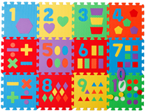

The Reception children will begin to recognise their numbers 0-5 in a range of ways, including numeral recognition. We will use a range of practical, real life problems to draw out the children’s thinking through mathematical discussions and learning opportunities in the environment. We will also explore sorting and classifying of objects into different groups. The children will be encouraged to record their mathematical thinking in a way that is meaningful to them.

Year 1 and 2 will be following the White Rose maths curriculum with the focus this term on place value to 20 and 100, addition and subtraction including money and multiplication.

**Literacy & English**

The development of Literacy here in Hazel Class is focused on the immersion of the children in a language rich environment, securing their enjoyment and engagement with the written and spoken word. 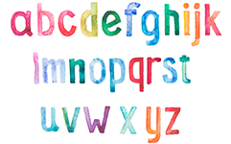

We will share a variety of high quality texts, both fiction and non-fiction to explore authorial voice and writerly craft in an age appropriate way. The children will be introduced to and deepen their love of storytelling through our *Favourite Five* books and lots of gorgeously written class novels.

Phonics is taught using the *Read Write Inc* programme which teaches children to read accurately and fluently with good comprehension. They learn to form each letter, spell correctly, and compose their ideas step-by-step.

The children in Reception will be encouraged and supported to mark make and write by tapping into their interests through a range of learning opportunities throughout the learning environment and through their Learning Play.

Year 1 and 2 will continue with their Read Write Inc sessions as well developing their reading and writing skills across the different subjects areas.

**This is Me****!**

As a new year begins and a new class enters Hazel, it is the perfect time for us all to get to know each other! In our welcome packs, you will have received a brown bag biography and family portrait strip; these will help form some of our getting to know me activities and learning opportunities on the first few days back at school.

The children will be provided with lots of opportunities to build new friendships, as well as strengthening existing ones.

**The World Around Us - Forest School, Science & Geography**

We are extremely lucky that our lovely school is set in such a breathtaking position overlooking a beautiful patchwork of fields. Over the course of the year, Reception will have a half term at Forest School with Pete from Forest & Beach, as well as welly walks with Miss Cose and Miss Elliott. These opportunities allow the children to engage with and explore the local area, it’s the fields and hedgerows. We look at the variety of wild plants and flowers growing in the fields, hedgerows and sand dunes. We will also observe and describe the seasonal changes we notice over the coming months.

In geography we  will be developing our understanding of seasonal changes and the effects they can see on their environment around them., the affects of climate change on the environment, wildlife and on humans.  They will be using first hand evidence, photographs and welly walk field trips to recognise and identify these changes throughout the coming months.

Our science learning is titled Animal Safari where we use our previous leaning to help develop our understanding of animals, their habitats, food and off spring.

**Sir Francis Drake - History**

The children will be pulling on their historical hats and becoming historians to explore the question - Sir Francis Drake: pirate or hero?  They will develop an awareness of the past, using common words and phrases to help them understand the passing of time. They will begin to explore and identify how as historians we can represent the past by creating their own timelines to represent the key events.

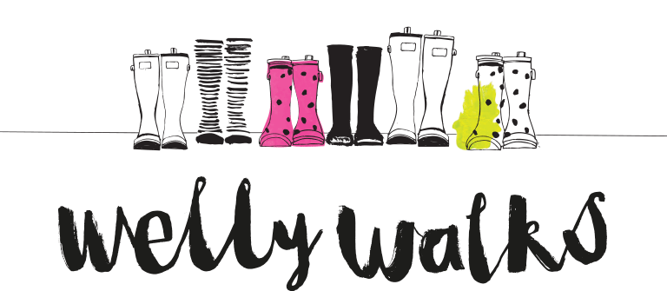

**Religious Education**

As global citizens, the Reception children will be looking at belonging and being special. This ties in beautifully with their *This is Me* learning over the first half term. As Christmas is a very important time to Christians, we will spend lots of time exploring the story of the Nativity through storytelling and discussion about Advent and the importance of Jesus’ birth.

**Art & Design**

As artists and designers in Hazel, we will be investigating and experimenting with a range of drawing, painting and 3D construction materials. The children will create their own self-portraits using a range of materials and techniques. The children will be introduced to simple colour techniques, including colour mixing, shade and tone. We will also learn about artists and some of the techniques they used to create their art. We will also learn about local  artist Brian Pollard and some of the techniques he uses to create his art.

**Technology**

As designers and constructors, we will be empowered to be inquisitive, curious learners. We will be looking at a range of houses, including those in the village, and identifying key features before constructing them, linking to our learning in Geography. We will be using our sewing skills to create Christmas stocking.

**Computing**

As users and programmers of communication and information technology, we will develop our computational thinking, logical reasoning and digital literacy through using different programmes.

**PE**

As well rounded, active citizens we will have lots of opportunities for positive competition in sport and other activities to build character and self-discipline . The sport we will be focusing on this half term is tag rugby, the children will be learning the skills needed to partake in games and understand the rules.

**Christian Distinctiveness**

Through our daily Acts of Worship, we will reflect on how we demonstrate our Christian values in school and within our local and world communities. We also weave our Christian values into the children’s learning opportunities and activities. We will explore our new vision and values, as well as celebrating the key festivals of Harvest and Christmas, as well as marking Remembrance Day.

**Class Acts of Worship**

Each week, the children will join their friends in their Family Group to deepen their understanding of the themes covered in our whole school Acts of Worship. These sessions offer a wonderful opportunity for all children to come together and work collaboratively as a family.

**Home Learning in Hazel Class**

We value the support that parents and families provide from home. It enriches your child’s learning and helps them achieve the best that they can. In Hazel Class, we send home weekly home learning.

In Reception, this consists of Maths game for you to play with your child that promote their enjoyment and engagement with Mathematics. We also send a range of books home weekly to support their comprehension and the fabulous learning they are doing in their Read Write Inc sessions. Occasionally, we may set a special project, investigation or experiment for you to work on together at home!

**Reading, Reading, Reading!**

Regular reading is of HUGE importance to the Literacy and social development of our young children. In the early days of school, it is vital that we ignite the children’s love of books and reading.

You can support your child’s reading at home by encouraging them to:

* Name any sounds they recognise, such as the ones they see in their name.
* Ask them to predict the ending to the story and explain why.
* Ask questions to help them understand and enjoy the story.
* Listen to a wide variety of pleasurable books.
* Continue to read a variety of stories to your child so that they are hearing a variety of story language and develop a love of reading.
* Don’t forget bedtime stories are still important too!